A.GOURI SHANKAR REDDY

192210105

1.Write a program to read in two integers and perform the following operations on them: addition, subtraction, multiplication, division, and modulo

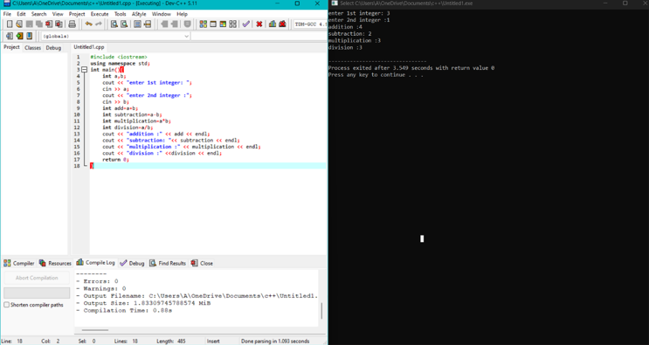

2. Program to determine the integer is odd or even

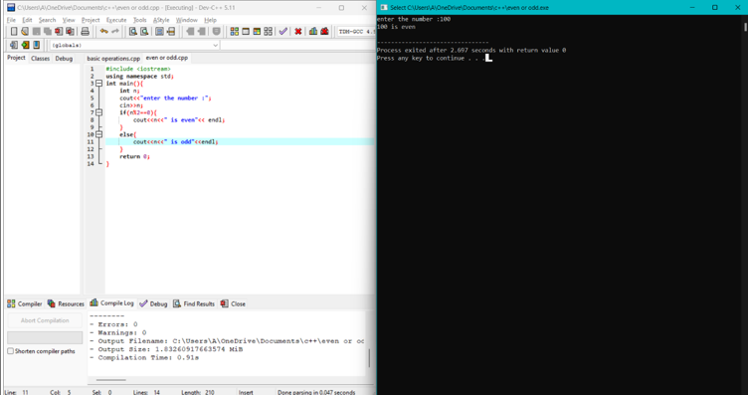

3. Program to compute the average of three integers

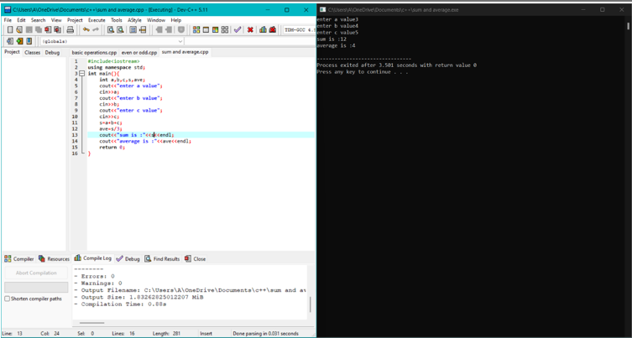

4. Program to check two numbers are equal or not

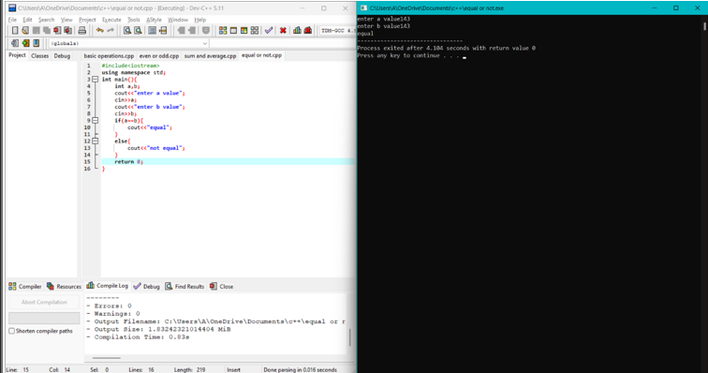

5. Write a program to read in two Floating numbers and perform the following operations on them: addition, subtraction, multiplication, division, and modulo.

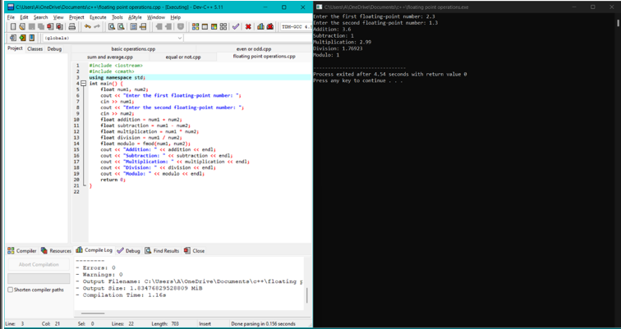

6. Program to check the character is a vowel or consonant

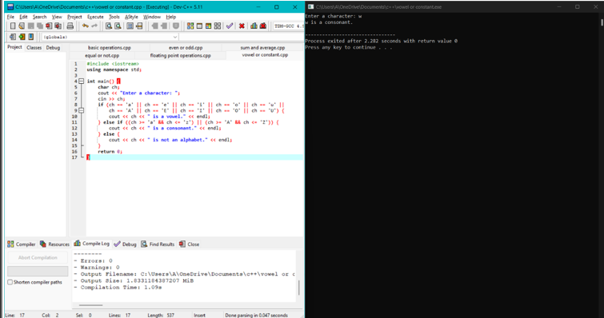

7. Program to check the number is positive, negative or zero

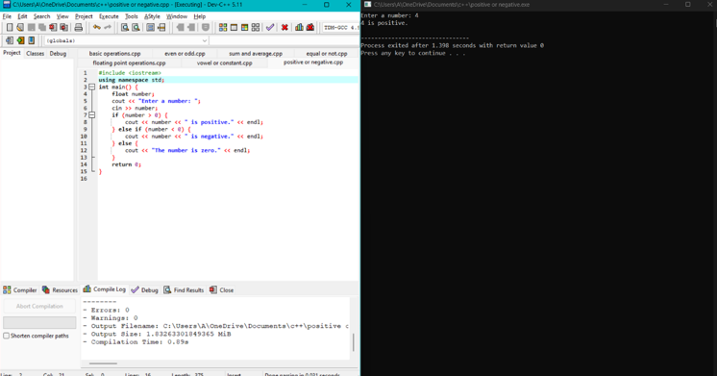

8. Program to determine which number is greater among two integers

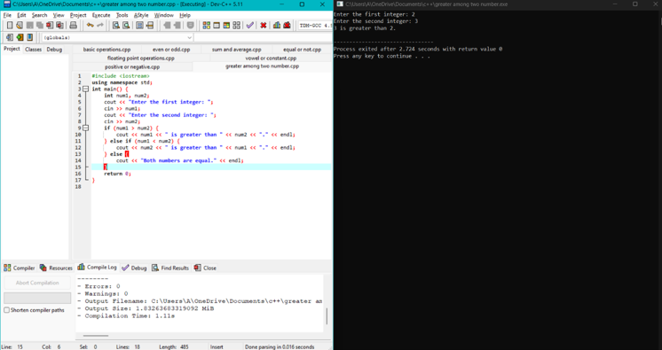

9. Program to read a floating-number and round it to the nearest integer using the floor an ceil functions.

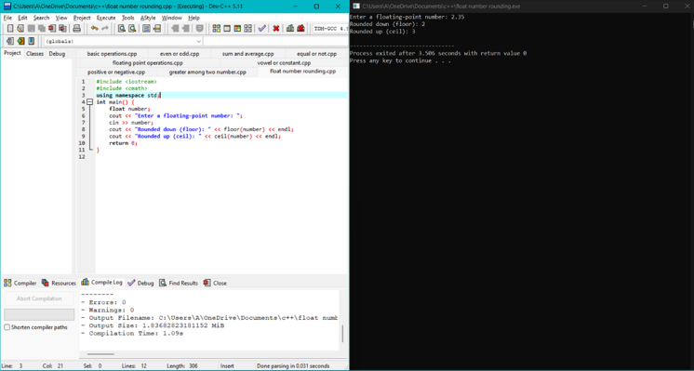

10. Program to swap two numbers using bitwise XOR operator

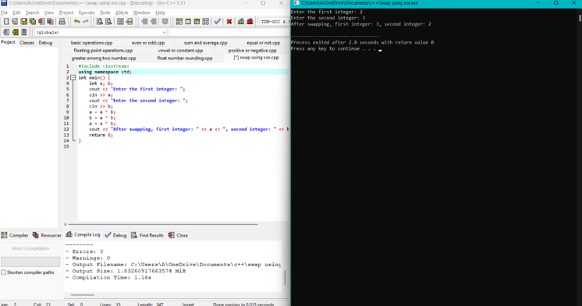

11. Largest among three numbers using ternary conditional operator

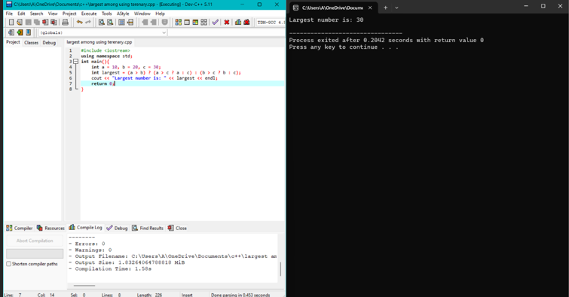

12. Program to check two numbers are equal or not using ternary conditional operator

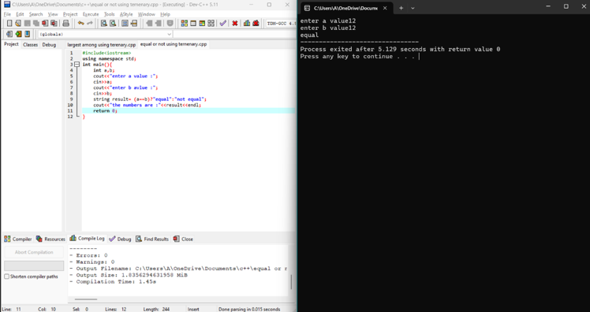

13. Program to check the integer is divisible by 3 or not using ternary conditional operator

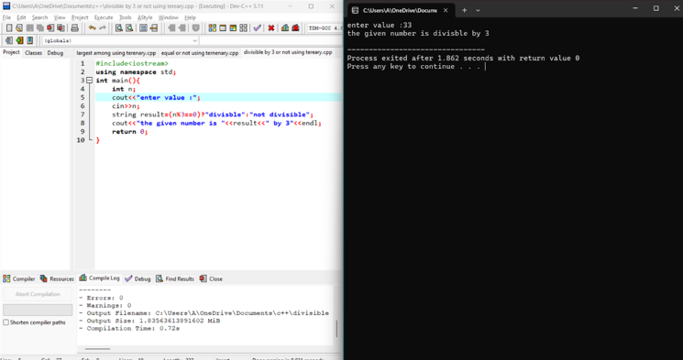

14. Program to print numbers from 1 to 10 using for loop

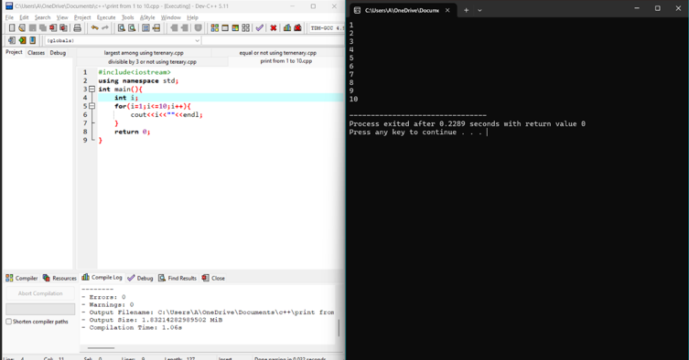

15. Factorial of a number using for loop

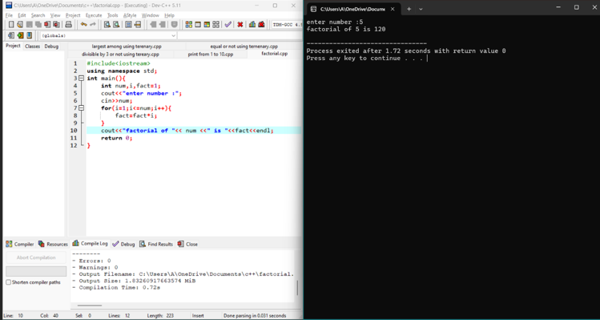

16. Print multiplication table using for loop

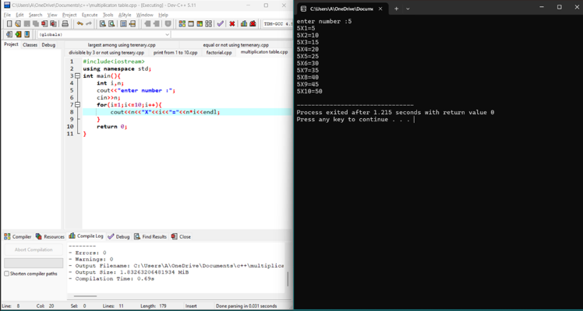

17. Fibonacci series using for loop

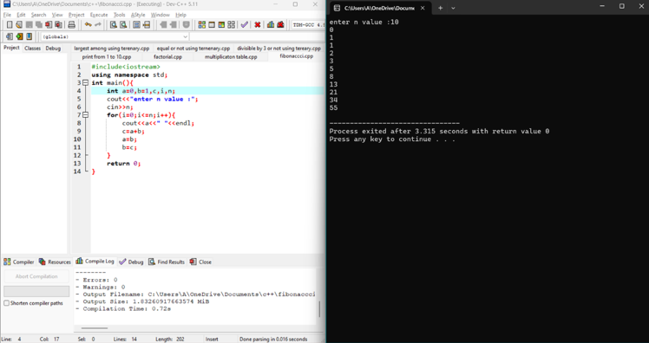

18. Prime number using for loop

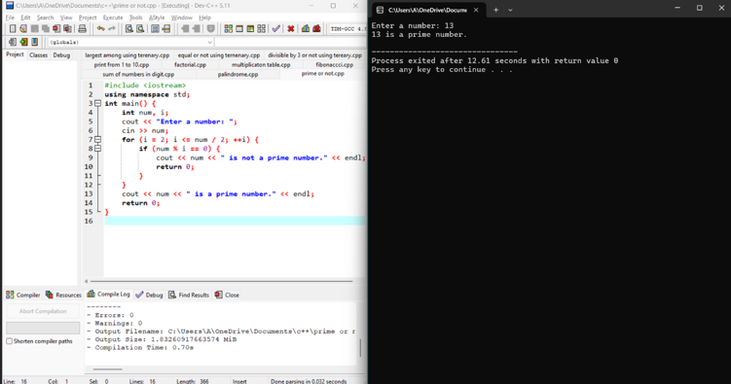

19. Check the string is palindrome or not using while loop

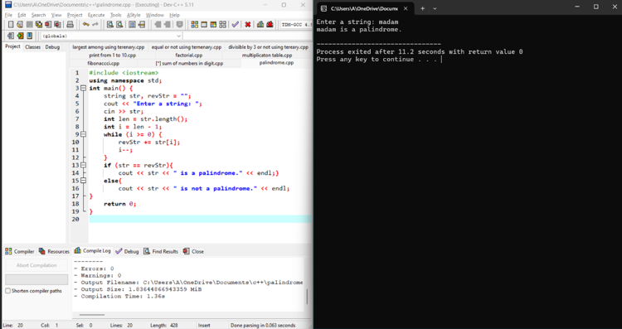

20. Sum of all digits using while loop (n=123 output:1+2+3=6)

